**OptiWiz User Manual**

1. What is OptiWiz?

OptiWiz is a generic solver and optimization calculator application. It contains solvers and calculators for the particular topics such as Polynomial Regression, Quadratic Spline Interpolation, and Simplex Method.

1. How to use the application?

First, if you open the application, you will be directed to the Home Page.

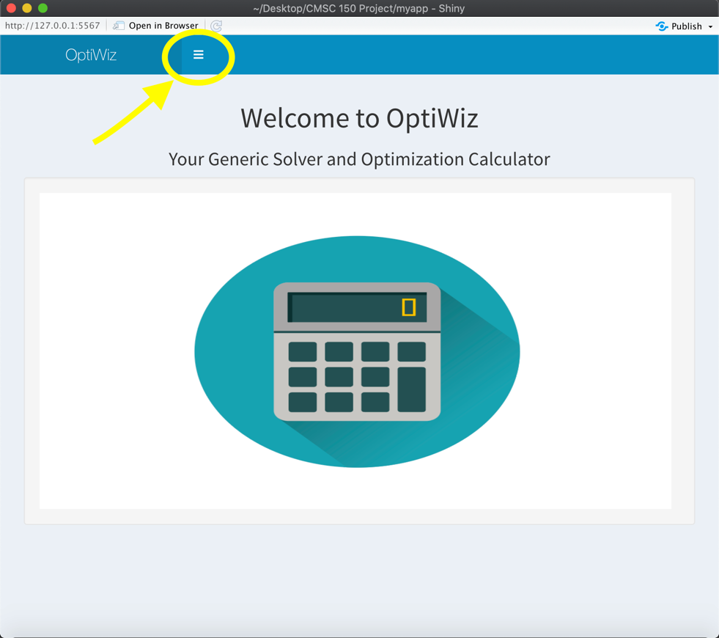

The button inside the yellow circle will help you navigate throughout the app. Let’s see what is inside…

So, inside side bar menu, we will 3 more menu namely Polynomial Regression, Quadratic Spline Interpolation, and Simplex. Click the menu of your desired page in order to perform the solvers.

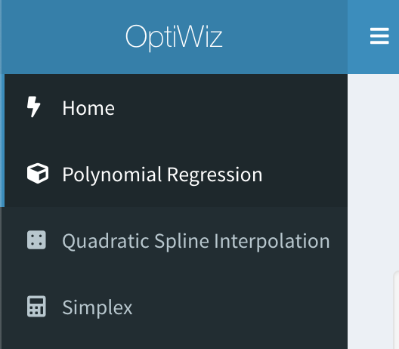

In the **Polynomial Regression** page, you will see 4 different section:

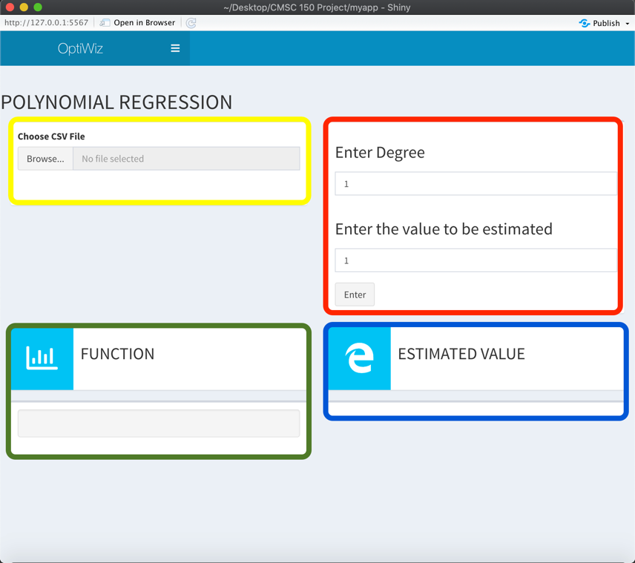

**Yellow Mark**: File Input (.csv files only)

**Red Mark**: Numeric inputs for the degree of the function and the value to be estimated

**Green Mark**: Displays the function depending on the degree input of the user

**Blue Mark**: Displays the estimated value of the function depending on the value input of the user

In the **Quadratic Spline Interpolation** page, you will also see 4 different section:

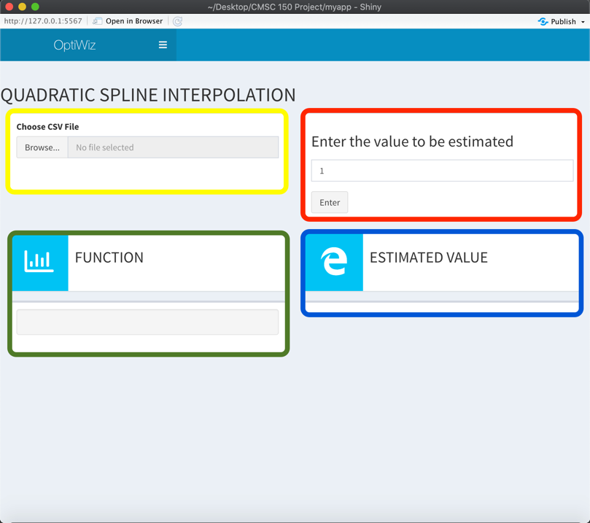

**Yellow Mark**: File Input (.csv files only)

**Red Mark**: Numeric inputs for the value to be estimated (The value must be within the range of x values)

**Green Mark**: Displays the function per interval

**Blue Mark**: Displays the estimated value of the function depending on the value input of the user

**Simplex Page (Upper Section)**

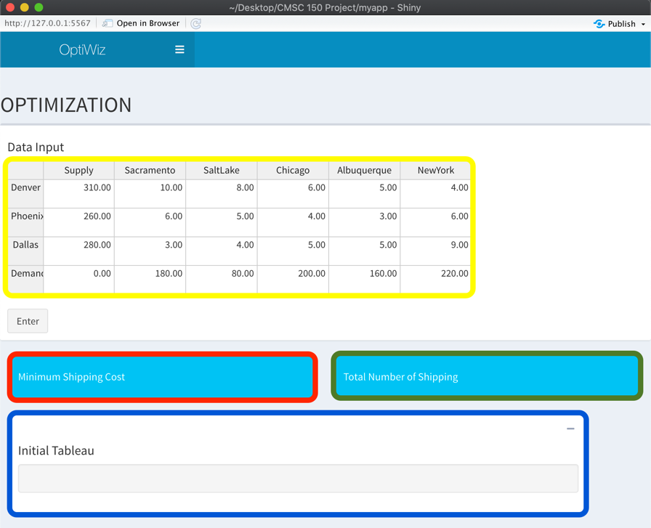



**Yellow Mark**: Table for the data input (This table is editable for easy data input manipulation)

**Red Mark**: Displays the minimum shipping cost of the problem based on the data input of the user

**Green Mark**: Displays the total number of shipping based on the data input of the user

**Blue Mark**: Displays the initial tableau of the problem

**Simplex Page (Lower Section)**

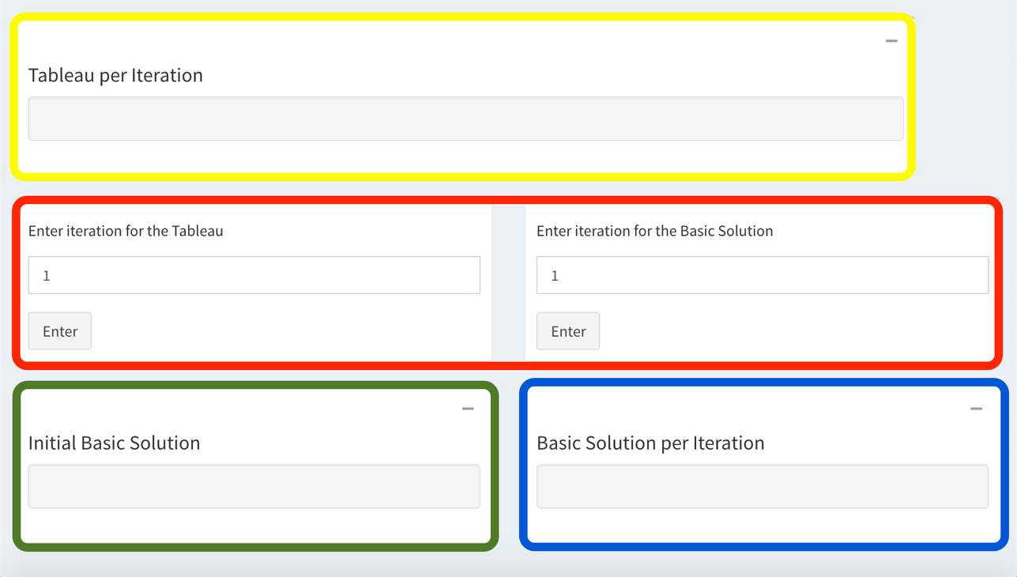

**Yellow Mark**: Displays the specific iteration of the tableau depending on the numeric input by the user

**Red Mark**: Numeric input for the desired iteration of the user (The one on the left side is for the tableau and the one right side is for the Basic Solution)

**Green Mark**: Displays the initial table for the basic solution

**Blue Mark**: Displays the specific iteration of the Basic Solution depending on the numeric input by the user

1. About the Developer

**Daniel Pete M. Aguilar** is an undergraduate BS Computer Science student at University of the Philippines Los Baños. He loves food and he also play basketball. He lives in the City of Valenzuela, or most commonly known as the Vibrant City.